____________________________________________________________FILE ONE : THE MEDIA

DOCUMENT 1

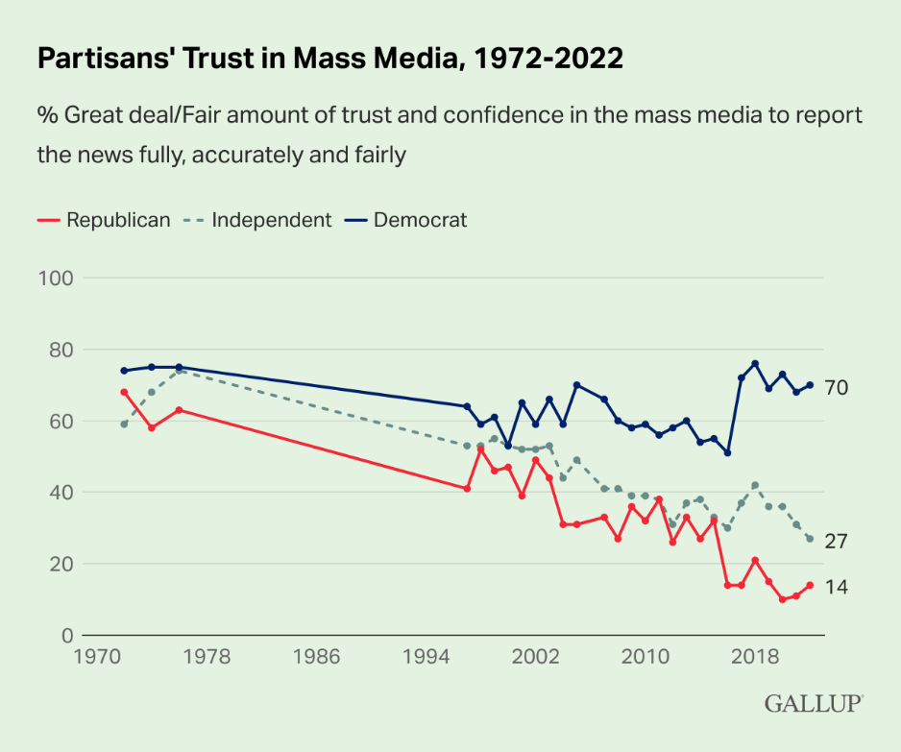

The Document 1 is a line graph that represents the percentage of Americans’/ American people’s trust in the mass media (traditional media/ news outlets /the press, television, the radio… vs online/digital media , social media platforms)

Political leaning = they identify as Republicans, Democrats or independents

From the 70s ….up to nowadays

In the 70s…..about 75% Republicans/ roughly78 % Democrats/ Almost-nearly two-thirds/ More than half Independents trust mainstream media for reliable information.

According to them traditional news outlets are trustworthy.

The 70s = the heydays of investigative journalism (Watergate scandal, Vietnam War…)/ to hold politicians accountable/

In the 70s trust in journalism was at an all-time high

Over the next decades, this trust has slowly diminished whatever the political party people belong to

From 2002 until 2017, trust has fluctuated

2017 was a turning point with the election of Donald Trump.

During his mandate Donald Trump kept attacking mainstream media ( CNN, NY times) / he was at loggerheads with the media, except Twitter or Fow News (pro-Trump TV channel)

In the wake of the Capitol attacks he was banned from Twitter and created Truth Social (his own social media platform)

In 2017 , Democrats’trust in media spurt/skyrocketed

The more DT criticized the media, the more Democrats trusted them.

Conversely, Republicans’trust plunged/plummeted… which means they were influenced by Trump’s stance.

In 2020 Republicans’ trust in the media hit an all-time low.

DOCUMENT 2

When Americans Lost Faith in the News

The New Yorker, January 2023

When the Washington Post unveiled the slogan “Democracy Dies in Darkness,” on February 17, 2017, people in the news business made fun of it. “Sounds like the next Batman movie,” the New York Times’ executive editor said.
But as soon as Donald Trump took office, he started calling the news media “the enemy of the American people.” “Fake news” became a standard White House response to stories that did not make the President look good. There were many such stories.
Suspicion is, for obvious reasons, built into the relationship between the press and government officials, but, normally, both parties have felt an interest in maintaining at least the appearance of cordiality. Reporters need access so that they can write their stories, and politicians would like those stories to be friendly. Reporters also want to come across as fair and impartial, and officials want to seem cooperative and transparent.

Trump waged war on the press, and persuaded millions of Americans not to believe anything they saw or heard in the non-Trumpified media.

The press wasn’t silenced in the Trump years. The press was discredited, at least among Trump supporters. It was censorship by other means. Back in 1976, even after Vietnam and Watergate, seventy-two per cent of the public said they trusted the news media. Today, the figure is thirty-four per cent. Among Republicans, it’s fourteen per cent.

That we need a free press for our democracy to work is a belief as old as our democracy. Hence the First Amendment. Without the free circulation of information and opinion, voters will be operating in ignorance when they choose whom to vote for and what policies to support. But what if the information is bad? What if you can’t trust the reporter? What if there’s no such thing as “the facts”?

The notion that good journalism is “objective”—that is, nonpartisan and unopinionated—emerged as a response to growing skepticism about the whole idea of stable and reliable truths. In other words, objectivity was a problematic concept from the start.

The classic statement of the problem is Walter Lippmann’s book “Public Opinion,” published a hundred and one years ago. Lippmann’s critique remains relevant today. His argument was that journalism is not a profession. You don’t need a license or an academic credential to practice the trade. All sorts of people call themselves journalists. Are all of them providing the public with reliable and disinterested news goods?

Lippmann had another point: journalism is not a public service; it’s a business. The most influential journalists today are employees of large corporations, and their work product is expected to be profitable. When ratings drop, and with them advertising revenues, correspondents change, anchors change, coverage changes. News, is curated for an audience. So, obviously, is the information published on social media, where the algorithm selects for the audience’s political preferences. It is hard to be “objective” and sell news at the same time.

The power of the press, such as it is, is like the power of academic scholars, scientific researchers, and Supreme Court Justices. It is not backed by force. It rests on faith: the belief that these are groups of people dedicated to pursuing the truth without fear or favor.

Using documents 1 and 2 answer the following questions

Do Americans still trust the media ?
How does the journalist explain this evolution?
What is at stake here ?
Can the media still be referred to as The Fourth Power ?

THEME

Il y a plus d’un demi-siècle Emile Zola observait déjà « Tous les hommes de cinquante ans regrettent l’ancienne presse, plus lente, plus mesurée », désormais écrasée par « le flot déchaîné de l’information à outrance ». « Est-ce le journal qui a éveillé dans le public cette curiosité croissante ? s’interroge alors l’écrivain. Est-ce le public qui exige du journal cette indiscrétion de plus en plus prompte ? Le fait est qu’ils s’enfièvrent l’un l’autre, que la soif de l’un s’exaspère à mesure que l’autre s’efforce, dans son intérêt, de la contenter. »
Cent trente ans plus tard, ces mots résonnent encore, amplifiés par la dictature de l’info en continu et l’écho des réseaux sociaux. Mais l’auteur de Germinal blêmirait sans doute en découvrant ce que l’époque actuelle charrie d’inquiétudes nouvelles. Secoué par une série de chocs sévères depuis le début du siècle-course à la gratuité en ligne, vieillissement du public, désertion progressive des points de vente, hausse des coûts du papier et de l’impression….-l’univers médiatique français a en effet été marqué ces dernières années par de nombreuses crises internes aux rédactions.
Le 1, Août 2023

VERSION
The article you are about to read was written by a human.
This kind of disclaimer will become an everyday occurrence as chatbots infiltrate deeper into our media space. It is becoming increasingly difficult to prove that a human is on the other side of a written or spoken communication.
How would I prove to you that these words were the product of human creativity and exertion? Perhaps through the originality of an idea or the novelty of a turn of phrase? Maybe by cracking a joke or employing irony? How about by expressing humane empathy as only a human could supposedly do?
Just how fast AI is progressing and how deeply it is infiltrating the media was put on stark display recently when Germany’s largest tabloid, announced that it was laying off a third of its staff and migrating their functions to machines.
Beyond the devastating effect on employment and job security, there are the profound social and environmental consequences of this rapid dash to deploy AI in the media. Chatbots not only consume vast amounts of energy, they remain notoriously inaccurate, even delusional. And rather than admit they don’t know, they often simply invent facts.
Al-Jazeera, July 2023

