_______________________________________________________________OUTSOURCING IMMIGRATION

- Compréhension : Résumé analytique comparatif

Le candidat répond en anglais à la question posée en 350 mots, + ou – 10%, en identifiant et en comparant les informations pertinentes dans les documents du dossier, sans commentaire personnel ni paraphrase.

According to documents 1 and 2 in the dossier, are rich countries right to send their migrants to third countries? Reference to any other documents may be included if relevant. Answer the question in your own words (350 words).

DOCUMENT 1

Western countries are shipping refugees to poorer nations in exchange for cash
The Conversation, July 28, 2022

The U.K. government was due to begin its first deportation flight to remove asylum-seekers to the East African country of Rwanda on June 14, 2022, exactly two months after signing the U.K.-Rwanda agreement. The asylum-seekers were from several war-torn and politically unstable countries, including Syria, Sudan and Iran. Each year, thousands of people – many fleeing repressive governments or poverty – attempt to cross the English Channel in fragile boats in the hope of starting a new life in the U.K.
Boris Johnson, the U.K. prime minister, defended the U.K.-Rwanda deal in June 2022, saying it would “remove the illegal cross-Channel trafficking of people whose lives are being put at risk.”
In exchange for Rwanda receiving the deportees, the U.K. has paid the country about US$142 million to cover the initial costs of operating the program as well as economic development projects in Rwanda. The U.K. deportees were expected to integrate their lives into Rwandan social communities.
But the first Rwanda deportation flight did not take off as planned. The European Court of Human Rights, the regional judicial human rights body in Europe, issued what are called interim urgent measures to stop the scheduled flights. Such measures are most often issued in cases where there is imminent risk of death or torture.
But instead of abiding by the decision, the U.K. government not only stressed its commitment to deportation flights, it also signaled its intention to pull out of the European Court of Human Rights.
As a scholar of refugees and postwar reconstruction, I see the deportation flights to Rwanda as part of a growing list of what are euphemistically known as migrant deterrence practices. These practices are used by Western countries to deter future migration of mainly people of color from countries in Latin America, Asia, Africa and Oceania, collectively known as the Global South.
In exchange for money paid to the receiving country, asylum-seekers are sent to those poorer countries to enable wealthier nations to circumvent international legal obligations to those seeking asylum. The use of countries like Rwanda by Western states is on the rise. The recent U.S.-Mexico Migrant Protection Protocol and the U.S.-Guatemala “third country safe” agreement follow a similar principle.
Since 1992, Australia has had a mandatory detention policy for “unauthorized” arrivals, which have included asylum-seekers. Since 2001, it has also been removing asylum-seekers to Manus Island in Papua New Guinea and Nauru – a poor island country in the Pacific Ocean – for processing.
According to the United Nations High Commissioner for Refugees, “externalization of Australia’s asylum obligations has undermined the rights of those seeking safety and protection and significantly harmed their physical and mental health.”
Deportations to Rwanda are part of the U.K.‘s 2022 Nationality and Borders Act, a law that drastically changed citizenship and asylum rules in the U.K. The U.N. Refugee Agency has criticized the legislation on which the act is based for being at “odds with the United Kingdom’s international obligations under the Refugee Convention.” These obligations include “not expelling refugees who are lawfully in the territory except on grounds of national security or public order.”
Despite this, the U.K. and other European countries have continued to deport asylum-seekers to such places. According to Amnesty International, many of the deportees face arbitrary detention, kidnapping, torture and even death in the the countries where they’re sent.
In addition, studies have shown deportations like the kind that have taken place in Europe have caused long-term damage.
These include undue burdens on family members, such as loss of family income to meet basic needs, family separation that causes psychological damage including depression and trauma, especially in children.

DOCUMENT 2

PM speech on action to tackle illegal migration
Published 14 April 2022

For centuries, our United Kingdom has had a proud history of welcoming people from overseas, including many fleeing persecution. It is controlled immigration, through safe and legal routes, which enables us to make generous offers of sanctuary while managing the inevitable pressures on our public services such that we can give all those who come here the support they need to rebuild their lives, to integrate and to thrive.
But the quid pro quo for this generosity, is that we cannot sustain a parallel illegal system.
Our compassion may be infinite, but our capacity to help people is not.
The British people voted several times to control our borders, not to close them, but to control them.
So just as Brexit allowed us to take back control of legal immigration by replacing free movement with our points-based system, we are also taking back control of illegal immigration, with a long-term plan for asylum in this country.
To deliver it, we must ensure that the only route to asylum in the UK is a safe and legal one, and that those who try to jump the queue, or abuse our system, will find no automatic path to settlement in our country, but rather be swiftly and humanely removed to a safe third country or their country of origin.
That is why we are passing the Nationality and Borders Bill, which allows us for the first time to distinguish between people coming here legally and illegally. It will enable us to issue visa penalties against those countries that refuse to accept returns of foreign criminals and failed asylum seekers.
It will allow us to prosecute those who arrive illegally, with life sentences for anyone piloting the boats.
At the same time, we are expanding our immigration detention facilities, to assist with the removal of those with no right to remain in the UK.
So from today, our new Migration and Economic Development Partnership will mean that anyone entering the UK illegally may now be relocated to Rwanda.
This innovative approach will provide safe and legal routes for asylum, while disrupting the business model of the gangs, because it means that economic migrants taking advantage of the asylum system will not get to stay in the UK, while those in genuine need will be properly protected, including with access to legal services on arrival in Rwanda, and given the opportunity to build a new life in that dynamic country.
And let’s be clear, Rwanda is one of the safest countries in the world, globally recognised for its record on welcoming and integrating migrants.
There are currently 80 million displaced people in the world, many in failed States where governments can’t meet their aspirations. In an era of mobile connectivity they are a call or a text away from potentially being swept up in the tide of people smuggling.
The answer cannot be for the UK to become the haven for all of them.
We simply cannot have a policy of saying anyone who wants to live here can do so.
We’ve got to be able to control who comes into this country and the terms on which they remain.
And we must do this in the spirit of our history of providing refuge.
In that way we can more than play our part in offering sanctuary to thousands fleeing persecution.
But then of course other countries must play their part too.
And that is what I think is most exciting about the partnership we have agreed with Rwanda today because we believe it will become a new international standard in addressing the challenges of global migration and people smuggling.
Though the way ahead will be hard, and though we can expect many challenges and many obstacles to be thrown up against this plan, I believe this plan is the right way forward, because the people smugglers must be stopped in order to save countless lives; and because tackling illegal migration is precisely the way to sustain a safe, legal and generous offer of sanctuary to those in need, that is in the very best traditions of this country and the values we stand for in the world.

DOCUMENT 3

Le Royaume-Uni invente la délocalisation du droit d’asile
Charlie Hebdo, 17 Mai 2022 ·

C'est la dernière tendance en matière de mondialisation : la délocalisation d'êtres humains. Contre leur volonté évidemment. Le Royaume-Uni a annoncé que, dorénavant, les étrangers arrivés sans titre de séjour sur leur territoire - y compris donc les demandeurs d'asiles qui fuient la guerre - seraient renvoyés à plus de 6000 km de là, au Rwanda. Sans espoir de retour. Au mépris de toutes les conventions internationales. Et de toute humanité.

Que les pays européens fassent tout pour éviter que des migrants n’arrivent jusqu’à eux n’est pas une nouveauté. Agence Frontex, construction de murs ou installation de barbelés, accords plus que douteux avec la Turquie d’Erdogan ou avec les gardes-côtes libyens… on n’en était pas à une abomination près.
Boris Johnson a pourtant réussi à repousser les limites, avec la dernière innovation en la matière : le refoulement d’étrangers d’ores et déjà arrivés au Royaume-Uni vers le Rwanda, pays qu’ils n’ont (au moins pour la quasi-totalité d’entre eux) même pas frôlé lors de leur parcours migratoire. « Ce n’est pas nouveau que les États tentent d’externaliser au maximum leurs devoirs en matière de droit d’asile, estime Camille Le Coz, spécialiste des migrations, analyste au Migration Policy Institute Europe, à Bruxelles. Mais ça marque une étape supplémentaire.
Le Haut-Commissaire des Nations unies pour les réfugiés (HCR) est rapidement monté au créneau, estimant que « les personnes fuyant la guerre, les conflits et les persécutions méritent compassion et empathie » et qu’« elles ne devraient pas être échangées comme des marchandises et transférées de force à l’étranger ». Car à aucun moment les exilés en question ne sont consultés. Peu importe qu’ils aient affronté tous ces dangers pour retrouver une femme, un frère ou une tante au Royaume-Uni, ou pour goûter à la liberté occidentale. On les récupère à leur arrivée, et on les envoie dans une autre partie du monde. Comme des colis. « Erreur de destinataire ».
Boris Johnson, lui, joue l’offensé. Selon lui, cet accord serait avant tout destiné à éviter toutes ces morts tragiques dans la Manche, en décourageant les clandestins d’entreprendre cette périlleuse traversée. Et puis, après tout, le Rwanda serait « un des pays les plus sûrs au monde, internationalement reconnu pour son bilan d’accueil et d’intégration des migrants ».
Car beaucoup de spécialistes doutent de la conformité de cet accord avec les différents textes protégeant les droits de l’homme, et notamment avec la convention de Genève de 1951, qui réglemente le droit d’asile et prévoit le principe de « non-refoulement » des demandeurs d’asile et l’obligation d’étudier leur demande.
Des tentatives de découragement vouées à l’échec, selon Alexis Deswaef : « Pour travailler dans le domaine du droit des réfugiés depuis vingt-cinq ans, je peux vous dire qu’on ne quitte jamais son pays, son village, sa famille, sa langue… par plaisir. On fuit des guerres, des troubles, la misère… Quand on est prêt à le faire, qu’on prend le risque de traverser des mers, de se noyer, d’avoir affaire à des mafieux, d’être violé, d’être réduit en esclavage ou autre sur la route de l’exil, ce n’est pas un accord de ce type qui va dissuader les candidats à l’exil de tenter malheureusement le tout pour le tout. »

DOCUMENT 4 DOCUMENT 5

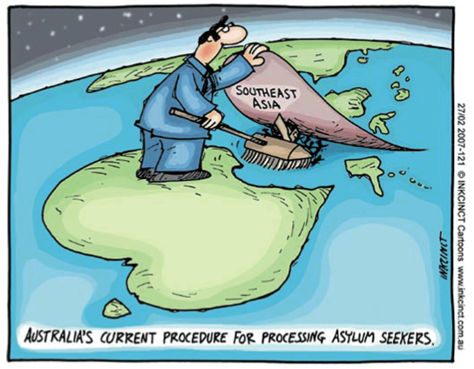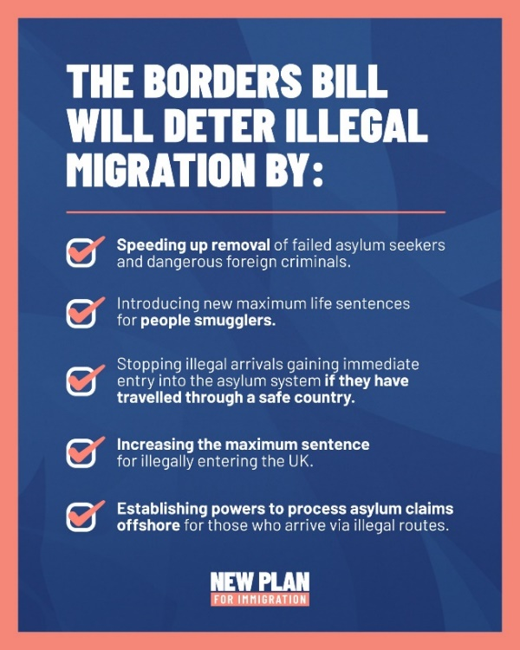

Source : Inkcinct.com (27/2/2007)

The UK Home Secretary outlined Britain's new plan for immigration

| Source: UK Home Office Twitter feed @pritipatel

Published on : 2021/03/24

- Expression personnelle : Rédaction argumentée
Le candidat répond en anglais à la question posée en 600 mots, + ou – 10%, dans la forme demandée, en réagissant au contenu du dossier, sans paraphraser celui-ci, tout en développant son opinion personnelle. Le candidat doit illustrer son argumentation avec des exemples culturels, civilisationnels et/ou historiques du monde anglophone.

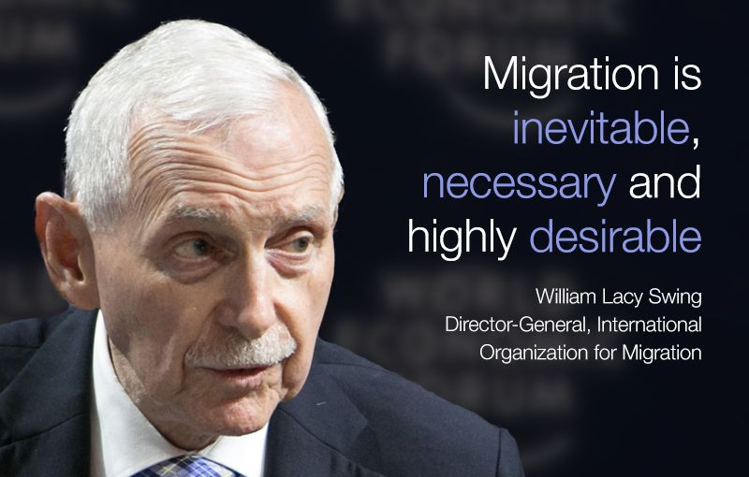
Write an essay of 500 words to comment on the quote above. Elaborate your personal opinions on this issue in your own words, supported by evidence and references drawn from Documents 1-5 and at least two other pertinent cultural, civilisational or historical references from the English-speaking world.

GOING FURTHER
https://theconversation.com/outsourcing-asylum-seekers-the-case-of-rwanda-and-the-uk-180973
https://www.aljazeera.com/opinions/2022/4/14/xenophobic-exclusion-has-become-a-british-tradition
https://www.youtube.com/watch?v=oxIxWIrPL-E
https://www.youtube.com/watch?v=67USa3Oi4SY

