___________________________________________________FILE 2 : UK’S HEALTH CRISIS

DOCUMENT 1

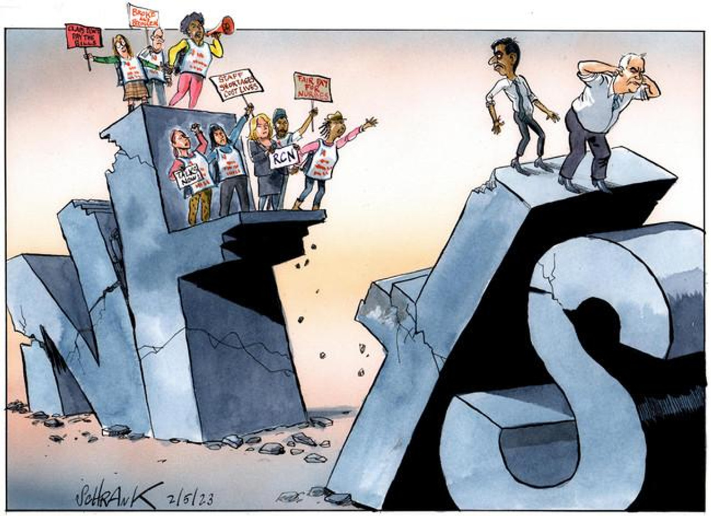

Peter Schrank, The Times, 02 05 23

DOCUMENT 2

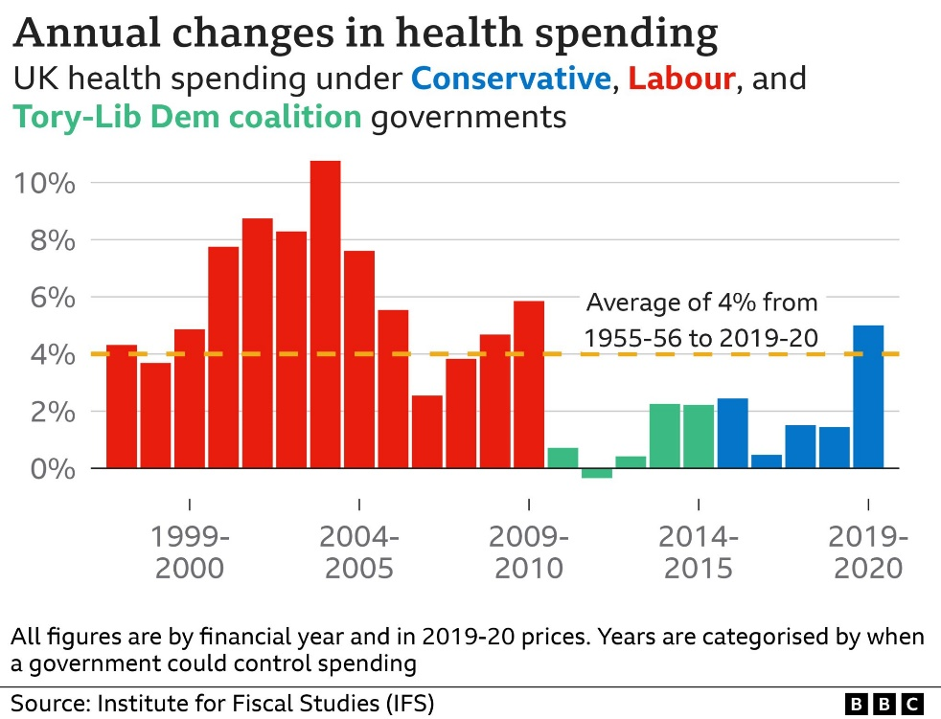

DOCUMENT 3

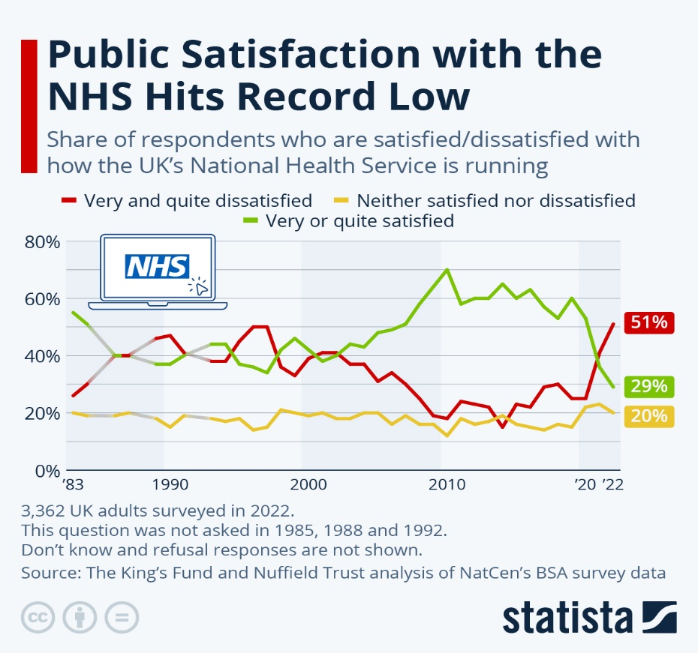

DOCUMENT 4

Why is Britain’s health service, a much-loved national treasure, falling apart ?
CNN, January 23, 2023

Founded shortly after World War II, the NHS is treated with an almost religious reverence by many. Britons danced for it during the 2012 London Olympics and clapped for it during the pandemic. “Our NHS” is a source of national pride.

Now, it is coming unstuck. There has long been an implicit contract between British people and the state: Pay taxes and National Insurance contributions in return for a health service that is free at the point of use.

But, with the tax burden on track to reach its highest sustained level since the NHS was founded, Britons are paying more and more for a service they increasingly cannot access as quickly as they need.

Some of these strains can be seen elsewhere in Europe. Doctors in both France and Spain have held strikes in recent weeks, as many countries face the same problems of providing care to an increasingly aging population – when inflation is at its highest level in decades.

Yet there are fears that the NHS is in worse shape than its international peers, and CNN spoke with experts who said they fear they’re witnessing the “collapse” of the service.
So how did Britain get here?

-When Covid-19 hit, the NHS went into full crisis-fighting mode, diverting staff and resources from across the organization to care for patients with the disease.
But, for many in the NHS, Covid-19 remains a crisis from which they are yet to emerge.
During the height of the pandemic, many ordinary practices were put on hold. Millions of operations were canceled. The NHS “backlog” has ballooned. Data from November showed there were more than 7 million people on a hospital waiting list in England.

-Even with the increase in funding since the pandemic, the UK is still playing catchup, after what critics say is more than a decade of underfunding the NHS.
“When the Labour government came in in 1997, they injected considerably more money into the NHS. It enabled us to appoint an adequate number of staff and get on top of our waiting lists,” Neville told CNN.
But this level of investment did not last. In response to the 2007-2008 financial crisis, the Conservatives elected in the coalition government in 2010 embarked on a program of austerity. Budgets were cut and staff salaries frozen.
During the austerity years, bed numbers continued to be cut, leaving the UK with fewer beds per capita than almost any developed nation, according to OECD data.

-The bed shortage has been made even more acute by the fact that many of those in hospital no longer need to be there – there is simply nowhere else for them to go. The problem is caused by a crisis in another sector: Social care. Patients that could leave the hospital end up staying there because they cannot access more modest care in a home setting and so cannot be safely discharged.
Health and social care are separate sectors in the UK system. Healthcare is provided by the NHS, whereas social care is provided by local councils. Unlike the NHS, social care is not free at the point of use: It is rationed and means-tested.
With an increasingly aging population – the latest census data show nearly 19% of the population of England and Wales is now 65 or older – demand for social care is increasing. But the sector is struggling to provide it in the face of staffing shortages, rising costs and funding pressures.

-The NHS is also reporting an alarming number of vacancies, with about 133,000 open positions as of September.
This points to a deeper crisis: Morale.
Jatinder Hayre, a doctor completing the foundation program at a hospital in East London, told CNN that morale is “at an all time low.” Staff are “stressed, fatigued, tired,” he said. “There doesn’t seem to be an end to this.”
“When you walk into the hospital in the morning, you’re met with this cacophony of grief and dismay and dissatisfaction from patients, who are lined up in the corridor,” Hayre said.
“You feel awful, but there’s nothing you can do. You’re fighting against a system that’s collapsing.”

The concern is that these issues get worse the longer they go untreated.
It is unclear how the NHS regains its footing.

Pay negotiations between the government and nursing unions have so far been unsuccessful. British media outlets have reported that Prime Minister Rishi Sunak may be considering offering a one-off hardship payment of £1,000 ($1,236) to attempt to resolve the dispute, but many feel this underestimates the true nature of the crisis.
“All I hear about is sticking plasters,” Neville said. “It depresses us all.”

