(DE) GLOBALIZATION
WORDS
Globalism : ideologies favouring globalization
backlash : réaction de rejet
to be left behind/out
goods and services
tariffs
border restrictions
subsidies : subventions
protectionism
free trade
World Trade Organization (WTO)=Organisation mondiale du Commerce

ISSUES
Ideas, knowledge, art, hospitality, travel - these are things which should in their nature be international. But let goods be homespun whenever it is reasonably and conveniently possible and above all let finance be primarily national
John Maynard Keynes . “Activities 1931-1939: world crises and policies in Britain and America”
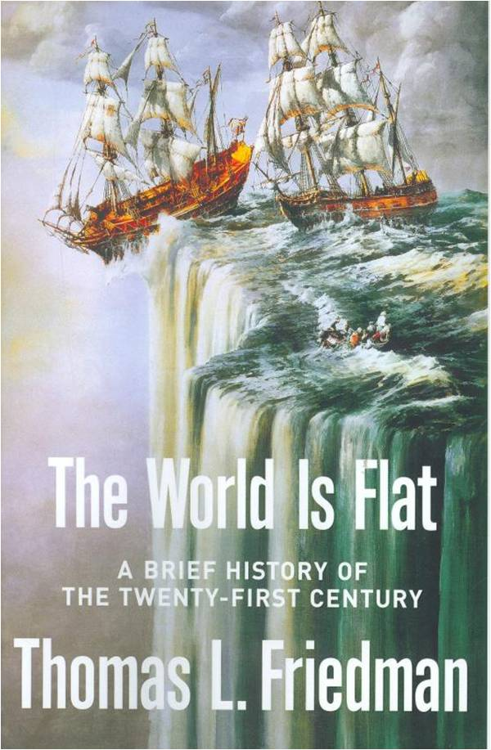
Devenu le prédicateur de la mondialisation heureuse Friedman

expliquait : « Le fait que deux pays ne se sont plus jamais fait la guerre depuis que l’un et l’autre ont accueilli des McDonald’s est aussi le produit de la puissance américaine et de la disposition à en faire usage contre ceux qui menaceraient le système de la mondialisation[...] La main invisible du marché ne peut pas fonctionner sans un poing caché »

Deglobalization is not a synonym for withdrawing from the world economy. It means a process of restructuring the world economic and political system so that the latter builds the capacity of local and national economies instead of degrading it. Deglobalization means the transformation of a global economy from one integrated around the needs of transnational corporations to one integrated around the needs of peoples, nations, and communities.
Walden Flores Bello (born November 11, 1945), Filipino academic , professor of sociology and public administration
We now have fund managers talking about 'deglobalization'. That's not to say free trade is dead and multinational corporations will have to go home. It means an era of protectionism is more likely than not. The World Trade Organization will be very busy with a Donald Trump White House. Asia, in particular China, is in the cross hairs. As is Mexico. Truth be told, we are currently experiencing the longest period of trade stagnation in 70 years. Political support for globalization policies of free trade and cheap labor is waning fast. (Forbes)

Videos

What Brexit means for globalisation | (Financial Times world)

What Trump presidency means for globalization
(CCTV English)

Francis Fukuyama: The Future of Globalization
(World Affairs)

Global Leaders See Globalization as Challenged, Not Failing

