COLLAPSOLOGY

La collapsologie, ce rêve autarcique qui fait des émules avec la pandémie

Le Figaro, le 8 juin 2020

Venu des États-Unis, ce mouvement «effondriste» croit au retour à la nature, loin du consumérisme et de la mondialisation. De plus en plus de familles changent de vie.
Certains vont s’investir dans une monnaie locale. D’autres dans la permaculture. D’autres encore vont simplement faire réparer leur vieux vélo et privilégier l’achat d’occasion… Longtemps marginaux et moqués, les adeptes de la collapsologie voient, avec cette pandémie du Covid-19, un regain d’intérêt pour leurs idées. Notre civilisation «thermo-industrielle», fondée sur les énergies fossiles, la consommation et la croissance, arrive à son terme, estiment ces «effondristes». De blogs en groupes Facebook, en passant par des ouvrages à succès, voilà en tout cas de plus en plus de Français convaincus de la nécessité de se préparer à une éventuelle catastrophe.

------------------

Collapsology’: Is this the end of civilisation as we know it? The Nation, April 2020
The world will never be the same again,” has been the oft-repeated refrain since the coronavirus brought the global economy to a juddering halt.
For many it has shown how fragile our civilisation is.
The crisis has come as a new movement called “collapsology” -- which warns of the possible collapse of our societies as we know them -- is gaining ground.
With climate change exposing how unsustainable the economic and social model based on fossil fuels is, they fear orthodox thinking may be speeding us to our doom.
The theory was popularised by a 2015 book, “How Everything Can Collapse”.
Some of its supporters believe the coronavirus crisis is another sign of impending catastrophe.

We should all be preppers
The Atlantic, May 2020

Preppers all over the world have been hunkered down safely at home or in their bunkers during the COVID-19 pandemic. For them, long-term food storage is a baseline, so making it through a season or two without venturing out is primarily a psychological challenge.
I’ve spent the past three years interviewing people preparing for an ambiguous future disaster, and some of them emailed me in the early days of the pandemic from their redoubts, expressing wry frustration as they watched shoppers on TV frantically stacking supplies—hand sanitizer, bottled water, and, yes, toilet paper—in their shopping carts. One wrote me, “These people are fixing a leaky roof in a rainstorm.”
Chances are you have a neighbor who was ready for this pandemic. And if you knew they were stockpiling before the disaster, you likely thought they were weirdos. I know I did, even as I traveled the world writing a book about them. Not anymore. Although preppers have long been the subject of ridicule, I imagine many of us will take on some of their habits, or at the very least make space in our closets and garages for nonperishables.

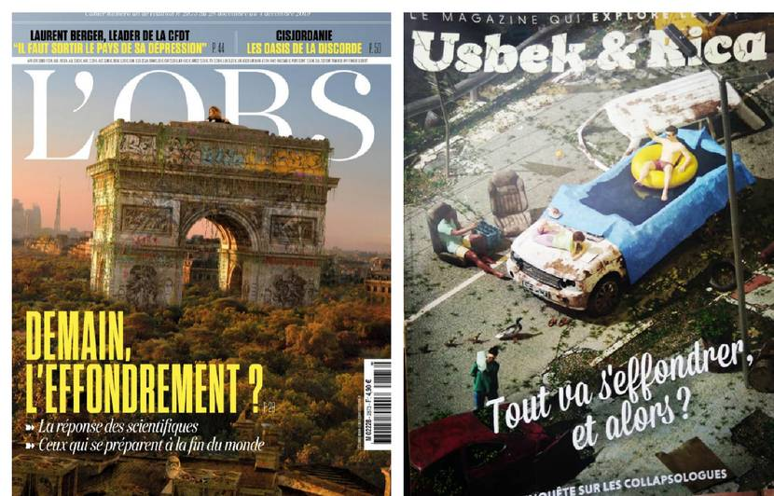

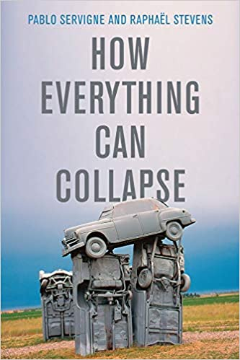
https://theconversation.com/la-collapsologie-a-lepreuve-de-la-realite-136727

Une leçon de collapsologie avec Pablo Servigne
https://www.youtube.com/watch?v=gJckUccWZ9Y

https://www.franceculture.fr/ecologie-et-environnement/theorie-de-leffondrement-la-collapsologie-est-elle-juste-une-fantaisie-sans-fondement

