ARTIFICIAL INTELLIGENCE

When the term “AI” was coined in 1955, it referred to machines that could perform tasks that required intelligence when performed by humans. It has come to mean machines that simulate human cognitive processes (i.e. they mimic the human brain in how they process). They learn, reason, judge, predict, infer and initiate action.
https://www.forbes.com/sites/forbestechcouncil/2017/02/27/why-2017-is-the-year-of-artificial-intelligence/#3a81c14457a1

Public discourse about AI invariably focuses on the threat of “superintelligent” machines, ie ones that display human-level general intelligence, even though such devices have been 20 to 50 years away ever since we first started worrying about them. The likelihood of such machines still remains a distant prospect, a point made by the leading AI researcher Andrew Ng, who said that he worries about superintelligence in the same way that he frets about overpopulation on Mars.
One might ask if our obsession with a highly speculative future has been deliberately orchestrated to divert attention from the fact that lower-level but exceedingly powerful AI is already here and playing an ever-expanding role in shaping our economies, societies and politics. This technology is a combination of machine learning and big data and it’s everywhere, controlled and deployed by a handful of powerful corporations, with occasional walk-on parts assigned to national security agencies.

Don’t worry about AI going bad – the minds behind it are the danger, The Guardian Feb 2018

À l'heure où l'intelligence artificielle gagne tous les secteurs, les robots n'ont pas encore conquis l'école française. Cette forteresse (stronghold)qui
semble imprenable (impregnable) n'est pourtant pas insensible (impervious to/unmoved by)aux sirènes ( the sirensong of) de l'IA.
De 6 à 8 millions d'euros devraient servir à financer la recherche et développement (R&D) de six solutions innovantes pour l'apprentissage du français et des mathématiques en primaire.
Cette manne (godsend) sera bienvenue.
La personnalisation est le principal intérêt de l'intelligence artificielle dans le domaine de la formation. De quoi permettre d'éviter le décrochage scolaire (school dropout), tout en tirant vers le haut (upgrade/pull upwards)les plus performants. «Aujourd'hui, rares sont les plateformes françaises qui ont réellement recours à (resort to)l'intelligence artificielle car cela requiert des investissements colossaux (enormous)»,
Nombreuses sont les start-up qui entendent bien ne pas rater le coche (miss the boat/the window);
Le Figaro, Mars 2018

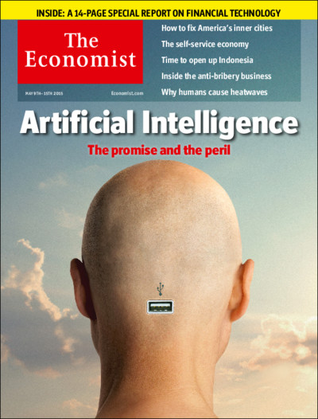

https://www.economist.com/news/science-and-technology/21737018-if-it-cannot-who-will-trust-it-artificial-intelligence-thrive-it-must

https://www.economist.com/news/leaders/21739658-artificial-intelligence-pushes-beyond-tech-industry-work-could-become-faireror-more

http://www.lemonde.fr/pixels/article/2018/03/31/pour-emmanuel-macron-l-intelligence-artificielle-est-aussi-une-revolution-politique_5279161_4408996.html

